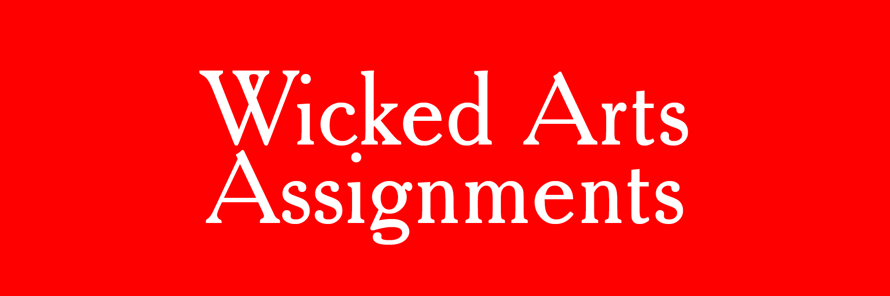

OPEN CALL - Deadline: January 15 2020
Your best, most challenging arts assignment
Wanted: Contributions for a new book on art education assignments

Emiel Heijnen and Melissa Bremmer will collect the 100 best and most challenging assignments in a book. Each assignment will be accompanied by an explanation, a biography of the artist or teacher and images of the sources of inspiration or elaborations of the assignment. In addition to the descriptions of the 100 assignments the book will contain a theoretical framework in which Heijnen, Bremmer and others will discuss educational design and strategies for making challenging art assignments.
This visually enticing book will be published by Valiz, Amsterdam, and is meant for a broad audience of art teachers, artists, educational experts and anyone who is interested in the practices of present-day art teachers. It offers inspiration for original and contrary lessons that reflect the themes, ways of working and concepts from international art and educational practices.

Wicked Arts Assignments:
- are bold, unusual, contrary, funny, poetical, inspiring, socially committed, or otherwise challenging;
- are concisely formulated, mainly in one or two sentences;
- are described more clearly with images of the end results of the participants or with examples of your own artistic work that is aligned with the assignment.

Please send this form (and your images) to: wickedartsassignments@ahk.nl
NAME
PLACE + COUNTRY

ASSIGNMENT 1
1. The assignment (1 or 2 sentences)

2. Short description of the assignment

3. Images can be send to: wickedartsassignments@ahk.nl

ASSIGNMENT 2
1. The assignment (1 or 2 sentences)

2. Short description of the assignment

3. Images can be send to: wickedartsassignments@ahk.nl

ASSIGNMENT 3
1. The assignment (1 or 2 sentences)

2. Short description of the assignment

3. Images can be send to: wickedartsassignments@ahk.nl

