Making a Thirdspace - Programme details

Saturday 25 May 2019
Breitner Academie, Overhoeksplein 2, 1031 KS Amsterdam

10.30 Registration and coffee
Welcome by chair Jappe Groenendijk (programme director Master of Education in Arts, Amsterdam University of the Arts)

11.00 Keynote lecture Dr Marike Hoekstra (Amsterdam University of the Arts): Artist teachers and democratic pedagogy

11.45 Keynote lecture Carol Wild (UK, University of Warwick/University of Birmingham): Both outside and in-between: What does artist-teacher practice do in formal schooling contexts?
12.15 Lunch break
13.00 Parallel sessions
Dr. Tobias Frenssen | Educating the art educator  Round table conversation | 2x 45 min | Rome
Marieke Hunze | A safe space to experiment  Workshop | 1x 90 min | Plek
Shailoh Philips | A Piece of Cake: connecting with things and forming assemblies of (non)humans  Workshop | 1 x 90 min | Belgrado
Vanessa Hudig | Close critique  Workshop | 2 x 45 min | Tokyo
Joanna Fursman | Looking for a New School Portrait (a school in a school)  Presentation, discussion and making | 2 x 45 min | New York
Ariadne Urlus | SKAR-lokaal  Round table conversation | 2 x 45 min | Rio de Janeiro
14.30 Coffee and tea break
15.00 Keynote lecture Rosa Wevers (University of Utrecht): The Museum of Equality and Difference (MOED)
15.45 Jappe Groenendijk Presentation of the publication “Kunstenardocenten en democratische pedagogiek” and final address
16.00 Drinks
All day: Exhibition Marike Hoekstra: Dioramas of democratic learning spaces Artistic research project. (Studio)
Marike Hoekstra, PhD.
BIO: Marike Hoekstra (1966) is an artist-teacher-researcher in the Netherlands. She holds MA’s in Russian Literature and Art Education. She published on the artist teacher and on altermodern art education. She works as a lecturer at the Academy of Fine Art in Education at the Amsterdam University of the Arts. In 2018 Marike graduated as a PhD at the Faculty of Education & Children’s Services at the University of Chester, UK. Her PhD research concerns the implications of the artist teacher for democratic pedagogical practice.
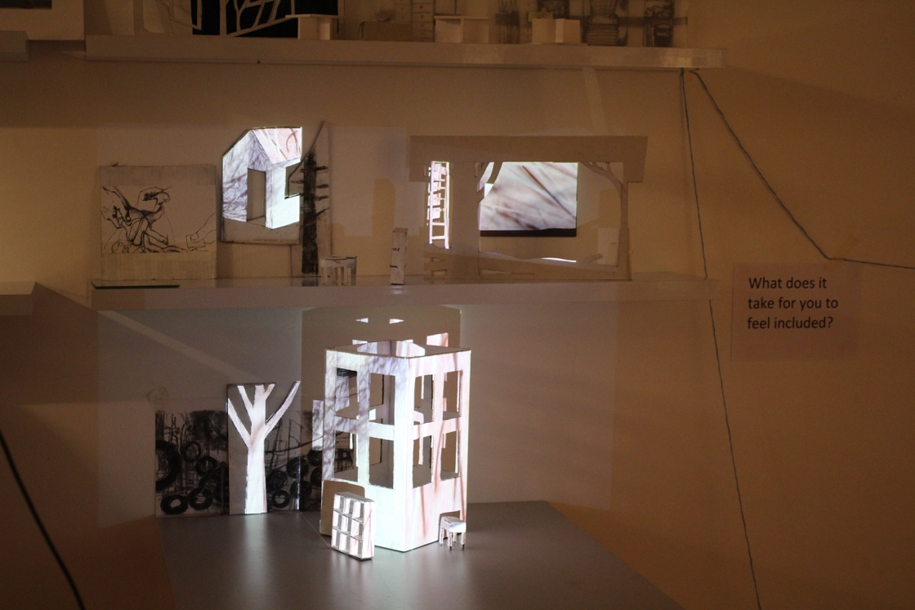
Keynote presentation: Artist teachers and democratic pedagogy
The binary opposition of artist versus teacher fails to comprise the diversity of practices where art making and teaching are combined. Not only does identification with artist or teacher vary, so does the extent to which the two disciplines are fused, to the point where it can be called a hybrid practice when the distinction between art and teaching is no longer relevant. The democratic nature of contemporary visual art making further problematizes a singular model of artist teacher practice. Central in this presentation is the notion of a pedagogical thirdspace. A spatial representation of social realities helps to create a critical understanding of human life. A thirdspace is a place in the margins between reality and ideals (Soja, 1999). When binary models of understanding are exchanged for real-life knowledge of the pedagogical practice of artist teachers an ambiguous open space emerges, where there is room for experiential learning, uncertainty, risk-taking, care, equality, inclusion, tacit experience, sensitivity, play, flexibility and conflict. The engaged pedagogy (hooks, 1994) of artist teachers emancipates learners because of the fact that the duality of the artist teacher invites learners to join in a democratic, living model of artistic practice.
Carol Wild
BIO: Carol leads postgraduate programmes in education, and has worked across all educational phases as artist, teacher, mentor, and researcher. She is interested in the history and changing practice of art and design education. Her PhD explores the construct of the Artist Teacher in the wake of the British initiative, The Artist Teacher Scheme.
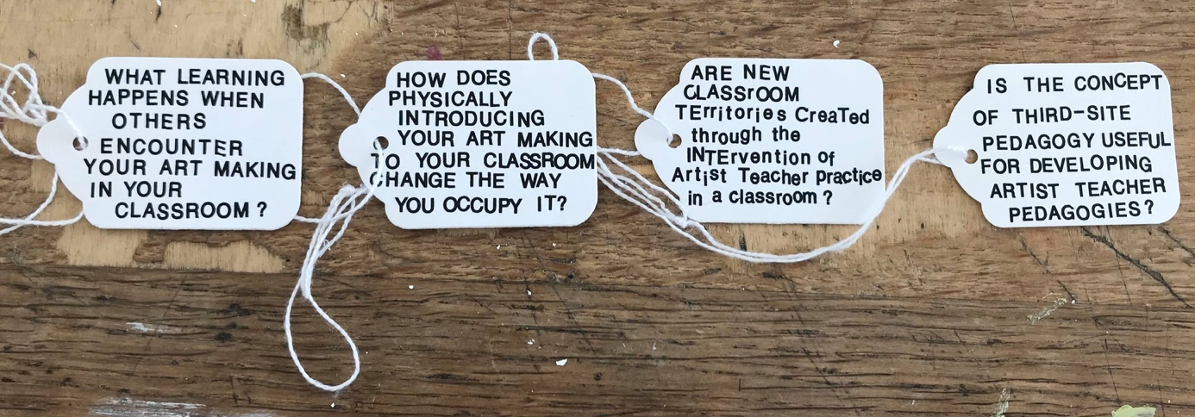
Keynote presentation: Both outside and in-between: What does artist-teacher practice do in formal schooling contexts?
The Artist Teacher Scheme (ATS) was established by Arts Council England and The National Society for Education in Art & Design in 1998, running for just over ten years before their sponsorship ended. Since then institutions involved have continued to run versions of the ATS, some to MA level, and several independently run Artist Teacher CPD courses have been established. But what does artist-teacher practice do? And what is its place within an education system dominated by neoliberal policy and practice?
Joanna Fursman
BIO: Joanna Fursman is an artist and PhD researcher at Birmingham School of Art, UK and leads BA Art and Education at Newman University, Birmingham. Her doctoral research titled: ‘performing on the surface of school, pedagogic art practice and the re-imaging of education’ proposes that the work of the image performs a re-organising of school.

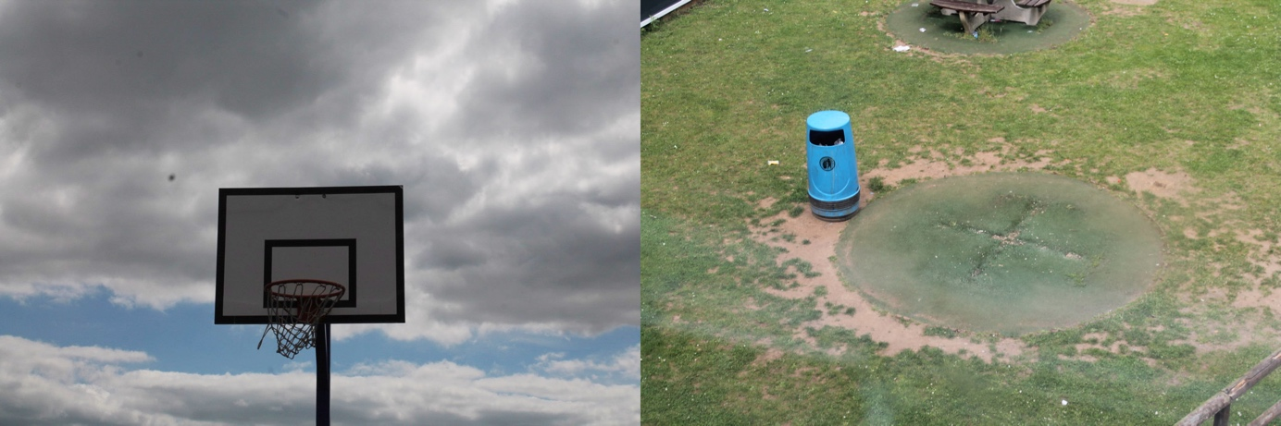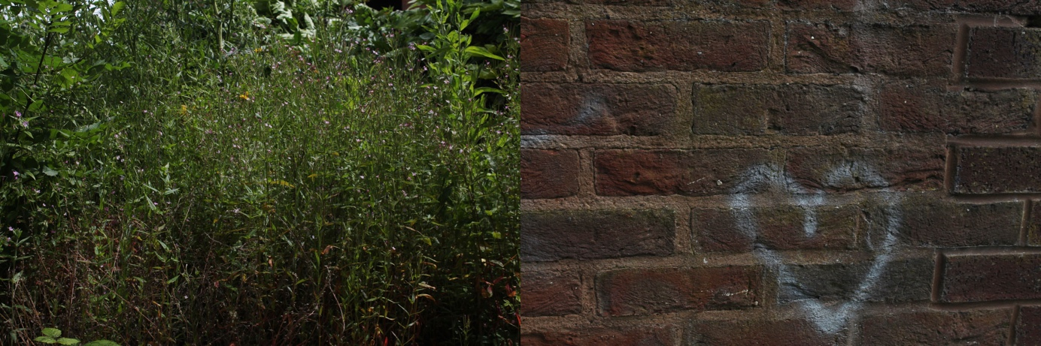

45 minute presentation, discussion and making workshop: Looking for a New School Portrait (a school in a school)

‘What is School’ explores three key artworks and examines where Third-Space School is located in their practice, production and relations with others. This influences my workshop proposal; ‘Looking for a new School Portrait’. Thinking how normalised images of school and the role of those in the re-production of ‘student’, ‘teacher’ or ‘learning’ fix what school is to certainty. ‘Looking for a New School Portrait’ will ask participants to collaborate in a performance of image making, where relations between others, materials and objects will be re-arranged and documented to examine where new images of school might emerge.
Ariadne Urlus
BIO: Trained both as an artist and arts manager, the professional interest of Ariadne Urlus (The Hague, 1964) is centered around developing and managing arts (educational) environments in the broadest sense of the word, in-school, out-of-school, through gallery education and talent development trajectories.
Her work history is formed by various positions in the art world, at some of the most interesting institutions of the Netherlands: as Head of Education at Witte de With, Director of Showroom MAMA, Manager at SKVR, as Business Manager at If I Can't Dance.
Currently, she is deeply involved in SKARlokaal: a concept based on a form of "embedded artistry": artists rent vacant spaces (through SKAR, hence the name) in or near a primary school, and from there, relationships evolve.

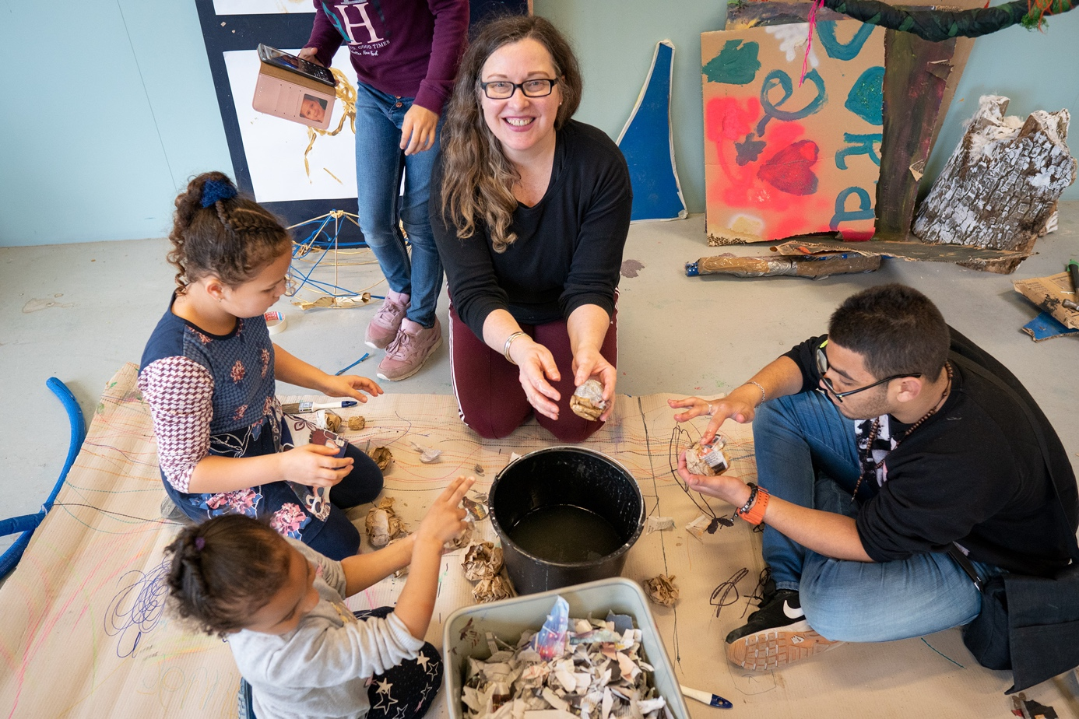

45 minute presentation and discussion: SKAR-lokaal

SKARlokaal investigates the idea of developing a learning environment in which artists work together with children, parents, neighbors, and teachers to enhance the agency of children and empower the neighborhood. Urlus – also in her role of student researcher at the Piet Zwart Institute – is particularly interested in the participation and ownership of children in SKARlokaal.
A first SKARlokaal is up and running in the South of Rotterdam (Zuidwijk), embedded in OBS De Toermalijn. Three more are on their way: one in the South (Charlois), one in the South East (Hoogvliet), and one in the North of Rotterdam (Oude Noorden).
Marieke Hunze
BIO: In 1989 I graduated an artist. In 2003 I started Lijm-lab, together with Brenda Jonker. Lijm-lab specializes in artprojects for schools and communities. Over the years we have created dozens of projects in all sizes: workshops, temporary artworks, performances and murals. In our workshops we try to trigger the imagination and playfulness of the participants, of any age.
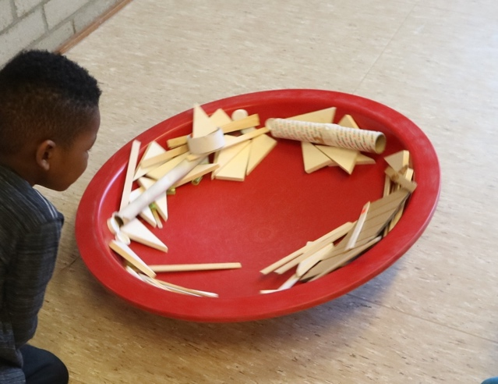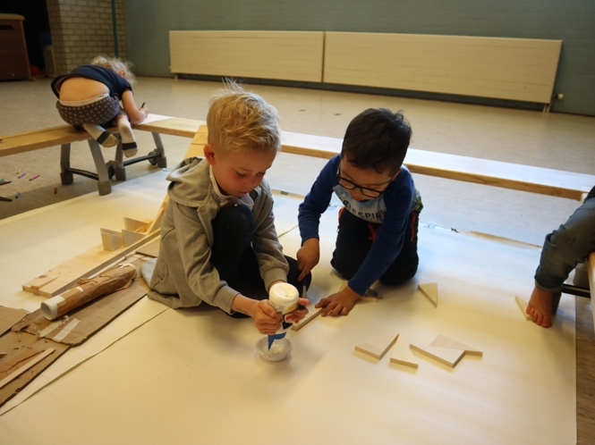
90 minute workshop: Lijm-lab
Having fun is the best way to learn and making art is a wonderful way to explore and communicate. In this workshop we are going to experiment with some everday materials. And by doing so try to answer the questions: What is it that makes a place a safe place to experiment? What do you need to turn this into a meaningful experience for children (or adults)? I’ll share my experiences in school situations and afterschool projects for children age 4-12. Lots of failures and fun, discoveries and disappointments.
Tobias Frenssen, PhD.
BIO: Tobias teaches art education at the art teacher colleges of the UCCL (Belgium) and Artez. He is an active research member of the centre of expertice Art of Teaching within UCCL. In december 2018 Tobias succesfully defended his doctoral thesis in art education at the University of Porto, Portugal.

45 minute round table discussion: Education for Art Educators - A study of what it could mean to be a teacher in higher education for art educators

The practice of the teacher within bachelor's and master's degrees for art educators is the research topic of Tobias’ PhD research. More specifically, in his thesis he describes and analyses the position of the teacher within e-ducational practices, which encourage students to study art education practice, in the competence-oriented context of European higher education. Jacques Rancière, a French philosopher, was an important source in his literature study. Rancière’s critical analysis of educational and artistic practices forms an important basis for the concepts that Tobias developed with the intention to describe the position of the teacher within e-ducational practices in higher education. In the thesis, art educational practices indirectly interfere with philosophical reflections and artworks. Throughout the chapters, with titles like "attention", "emancipation" and "the unknown", a story is built up with examples from, challenges for and ideas about education for art educators. The research took place at the University of Porto under the supervision of Catarina Martins.
Shailoh Philips
BIO: Shailoh Phillips is a transdisciplinary artist, theorist and educator. She is part of the collective Tools for Action and artistic researcher in the Critical Making Consortium. She teaches in the Master of Photography and Society (KABK) and Hacking (WdKA). She has a Master of Education in Arts and Design from Piet Zwart Institute.

90 minute workshop: A Piece of Cake: connecting with things and forming assemblies of (non)humans

Slowly, we are starting to realize that humans are not the only political creatures participating in producing and upholding social structures. This workshop is part of an ongoing quest for another way of being in this world, another way of teaching, another way of (un)learning together. What does it mean to decenter human agency in democratic pedagogical processes? How to speak and negotiate with nonhumans? We start with a cake (yes, a real cake) negotiating how to divide it based on playing with different roles and perspectives.

Vanessa Hudig

BIO: Vanessa Hudig teaches visual art and design at the Barlaeus Gymnasium in Amsterdam. Over the years she has been involved as an art teacher in different schools and as a designer in the teacher training programme ‘De Nederlandse School’. She combines her teaching activities with a training at the International Writers’ Collective, is working on a book which she writes and illustrates.

45 minute workshop: Close Critique

What are the implications of artist teacher practice for the process of feedback and assessment? Is objectivity affected by the artist’s own preferences, fascinations or allergies? These questions motivate a pedagogical relation based on trust, where artist teacher and artist learner engage in an open and constructive dialogue about the work.
In this workshop participants will experience how this critical position works by looking at student work or their own art work. Participants will become aware of the different roles artist educators have: the artist, the art teacher or the art expert. By combining various feedback techniques, a method of ‘close critique’ can be developed.
Rosa Wevers (MOED)
BIO: Rosa Wevers is MOED’s project coordinator, and teaches at the Graduate Genderstudies Programme at Utrecht University.
Keynote presentation Museum of Equality and Difference:
The Museum of Equality and Difference (MOED) is an online museum and research project that brings together artistic perspectives on equality and difference that strive for social change. MOED is a project by researchers of the Graduate Gender Program at Utrecht University. We aim to develop imaginaries of an inclusive society, centered around the questions: What does equality look like, for whom, and why? What does difference look like, for whom, and why?
MOED collaborated with the Centraal Museum (Utrecht) to curate the exhibition MOED: What is Left Unseen. The exhibition is on show until June 30, 2019.

